Chapter 2 Activity

Part I:
Taco Bell surveyed customers to determine which item on the menu they were least likely to order. Below are the results:
Survey Participant #
1 | 7-Layer Burrito
2 | Crunchy Taco
3 | Nachos Supreme
4 | 7-Layer Burrito
5 | Mexican Pizza
6 | 7-Layer Burrito
7 | Beefy Fritos Burrito
8 | Nachos Supreme
9 | 7-Layer Burrito
10 | Beefy Fritos Burrito
11 | Nachos Supreme
12 | Beefy Fritos Burrito
13 | Beefy Fritos Burrito
14 | 7-Layer Burrito
15 | Mexican Pizza

- Create a frequency distribution table of the Taco Bell data.
- What is the Σf
- Calculate relative frequencies and percentages for your table.
- If you had to select one item to remove from the menu, what would it be based on the data?
- What type of frequency distribution graph would you use to graph this data? Why?
- Based on your response, create the appropriate frequency distribution graph.
- What is your favorite taco bell menu item (if any)?
Activity inspired by: https://www.cnn.com/2020/09/03/business/taco-bell-new-menu/index.html

Part II: For each graph below, a) identify the type of frequency distribution graph shown and b) determine whether it is symmetrical, positively skewed, or negatively skewed distribution.
1.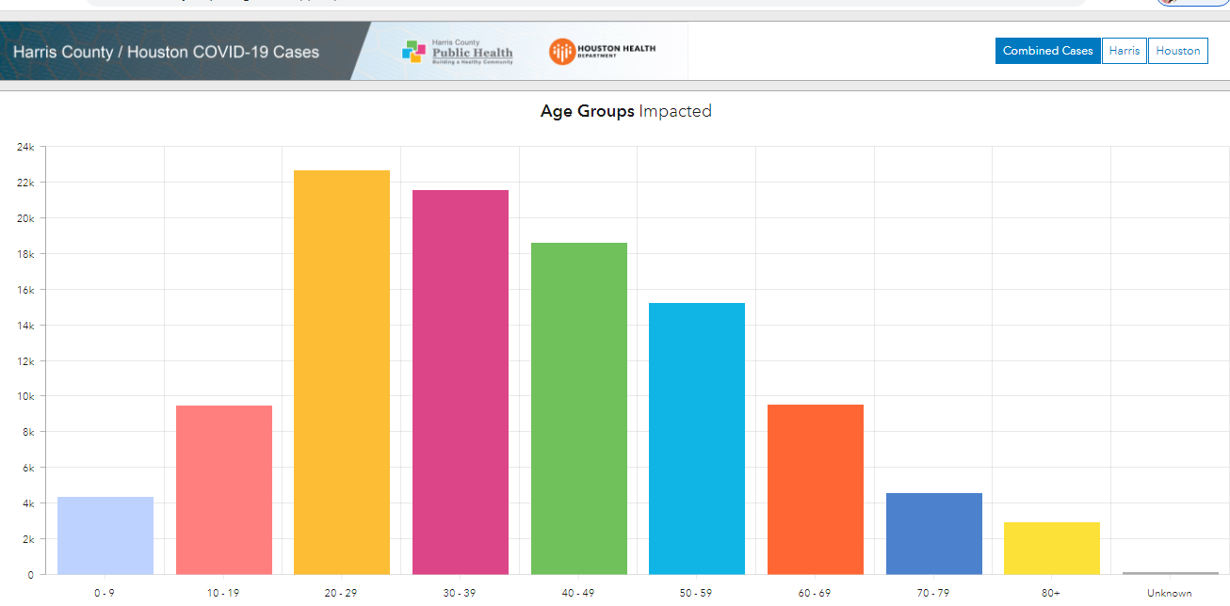

2. 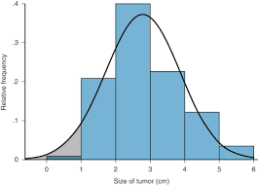

3. 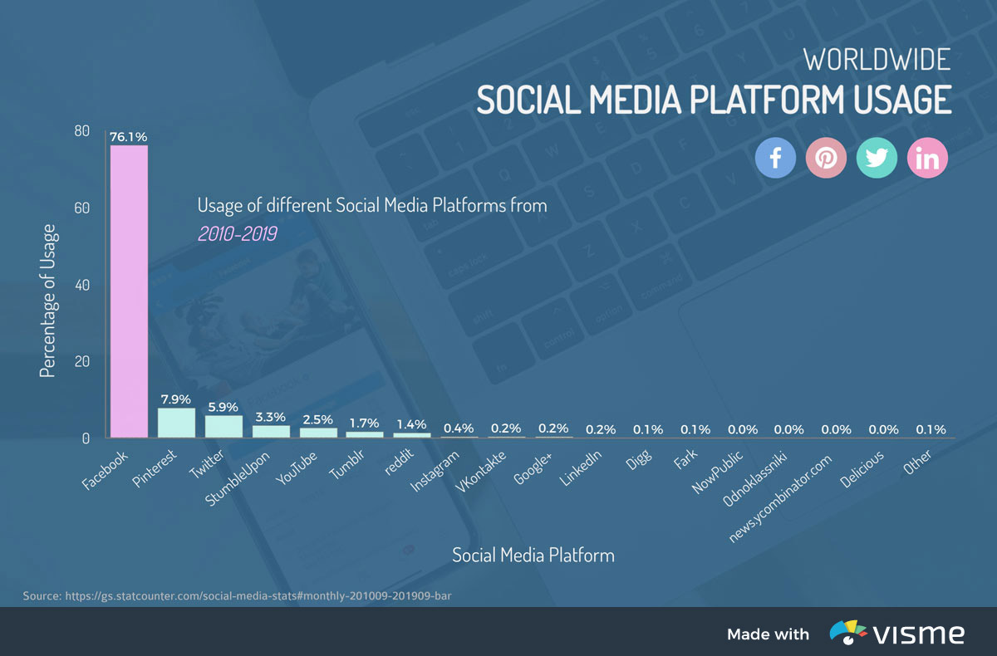

Part III: Solve for the ΣX for the frequency distribution graph shown below (hint: you will should create a frequency distribution table first.)

Is this a skewed distribution? If so, is it positively or negatively skewed?

